**ATHARVA EDUCATIONAL TRUST**

**ATHARVA COLLEGE OF ENGINEERING**

**MALAD, MUMBAI**



A MINI PROJECT REPORT ON

**“ONLINE FOOD ORDERING”**

SUBMITTEDBY:

**ANIKET PATIL (2)**

**SAKSHI JAIN (13)**

UNDER THE GUIDANCE OF:

**MISS KOMAL GOTHWAL**

**DEPARTMENT OF INFORMATION TECHNOLOGY**

**(2018-2019)**

# CERTIFICATE

This is to certify that the project entitled **“ONLINE FOOD ORDERING”** is a bonafide work of **ANIKET PATIL (2), SAKSHI JAIN (13),** submitted to the University of Mumbai in partial fulfillment of the requirement for the award of the degree of “**TEIT”** in **“IP”**.

(GUIDE SIGNATURE) (HOD SIGNATURE)

# Dissertation Approval Certificate

This project report entitled website on ONLINE FOOD ORDERING by ANIKET PATIL, SAKSHI JAIN is approved for the degree of Bachelor of Engineering in Information Technology.

Examiners

1.---------------------------------------------

Name:-

Date:-

Place:-

# Declaration

I declare that this written submission represents my ideas in my own words and where others' ideas or words have been included, I have adequately cited and referenced the original sources. I also declare that I have adhered to all principles of academic honesty and integrity and have not misrepresented or fabricated or falsified any idea/data/fact/source in my submission. I understand that any violation of the above will be cause for disciplinary action by the Institute and can also evoke penal action from the sources which have thus not been properly cited or from whom proper permission has not been taken when needed.

--------------------------------------

(Aniket Patil - 2)

--------------------------------------

(Sakshi Jain - 13)

Date:

**INDEX**

|  |  |  |
| --- | --- | --- |
| **Sr no.** | **Title** | **Page no** |
| 1 | Chapter I | 7 |
| 1.1 | Introduction | 7 |
| 1.2 | Problem Statement | 7 |
| 1.3 | Scope and Aim | 7 |
| 1.4 | Objectives | 8 |
|  |  |  |
| 2 | Chapter II | 9 |
| 2.1 | Hardware requirements | 9 |
| 2.2 | Software requirements | 9 |
| 2.3 | Other requirements | 9 |
|  |  |  |
| 3 | Chapter III | 10 |
| 3.1 | Code | 10 |
| 3.2 | Website snaps | 21 |
|  |  |  |
| 4 | Chapter IV | 24 |
| 4.1 | Conclusion | 24 |
| 4.2 | Future Scope | 24 |

**LIST OF FIGURES**

|  |  |  |
| --- | --- | --- |
| **Sr no.** | **Title** | **Page no** |
| 3.2.1 | Home Page | 21 |
| 3.2.2 | Login Page | 21 |
| 3.2.3 | Registration Form | 22 |
| 3.2.4 | Menu Page - Cuisine Types | 22 |
| 3.2.5 | Menu Page - Dish Types | 23 |
| 3.2.6 | Menu Page – Dish Details | 23 |

**Chapter I**

* 1. **Introduction**

Computer has become part of the life for accessing almost any kind of information. Life in the 21st century is full of technological advancement and in this technological age it is very difficult for any organization to survive without utilizing technology. The World Wide Web contributes greatly to the creation of an ever-increasing global information database. It could also be used as a mechanism to share information within an enterprise. So Online food ordering system is needed in this sector.  
Online food ordering system is the technique of ordering foods online. The user can simply login using his/her username and corresponding password and then order foods to be delivered to his/her specific location. Through Internet services, administration will have access of online information about key factors.

* 1. **Problem Statement**

Many restuarants are storing their data in a manual way. They serve ample customers in a day. So because large number of customers, they need help ie. Customer’s feedback. In the existing system, entering all the details are done manually so due to large data there are frequent chances of mistakes.

**1.3. Scope and Aim**

The scope of the system is that it will use Computerized Ordering System. The system views a notification that the order has been received based on the requirement of the system. Orders received will go to inventory system monitor the products. The system will have the database that stores all the order information of the customer.

The main aim is to simplify and improve the efficiency of the ordering process for both customers and the restaurants, minimize manual data entry and ensure data accuracy and security during order placement process. Customers will also be able to view product menus and will be able to have a visual confirmation that the order was placed correctly.

* 1. **Objective**

The general objectives of the study is to develop a reliable, convenient and accurate Ordering System. To develop a system that will surely satisfied the customer service. To design a system able to accommodate huge amount of orders at a time. To evaluate its performance and acceptability in terms of security, user-friendliness, accuracy and reliability. To improve the communication between the client and the server and minimize the time of ordering.

**Chapter II**

**2.1. Hardware Requirements**

PC with following configuration

1. Minimum Intel i3 processor
2. 4GB RAM
3. 500GB Harddisk

**2.2. Software Requirements**

1. Windows Desktop OS
2. HTML5 compatible web browsers (Chrome, Internet Explorer)
3. HTML, CSS editor like Notepad ++
4. XAMPP

**2.3. Other Requirements**

1. Internet Connection Installation of web framework.

**Chapter III**

**3.1. Code**

* Home Page:

<!DOCTYPE html>

<html>

<head><title>home page</title>

<style>

.login{

background-color:#4CAF50;

border:none;

color:white;

padding:16px 32px;

text-decoration:none;

margin:4px 2px;

cursor:pointer;

border-radius:50;

float:right;

}

body{

background:black;

}

.register{

background-color:#4CAF50;

border:none;

color:white;

padding:16px 32px;

text-decoration:none;

margin:4px 2px;

cursor:pointer;

border-radius:50;

float:right;

}

.login:hover{ background:blue;}

.register:hover{ background:blue;}

</style>

</head>

<body background="black">

<div>

<a href="login.php" class="login">Login</a>

<a href="registration.php" class="register">Register</a>

</div>

</div>

</body>

</html>

* Login Page:

<!DOCTYPE html>

<html>

<head><title>Login Form</title>

<style>

body{

margin:0px;

paddind:0px;

font-family:sans-serif;

background-size:1422px 700px;}

.box{

background: rgba(0,0,0,.5);

color:#fff;

width:320px;

height:420px;

top:50%;

left:50%;

transform:translate(-50%,-50%);

box-sizing:absolute;

padding:70px 30px;

float:right;

margin:25%;

}

.userimg{

width:100px;

height:100px;

border-radius:50%;

overflow:hidden;

position:absolute;

top:calc(-100px/2);

left:calc(50% -50px);

}

h2{

font-size:22px;

}

.box input{

width:100%;

margin-bottom:20px;

}

.box input[type="email"],input[type="password"]

{

border:none;

border-bottom:1px solid #fff;

background:transparent;

outline:none;

height:40px;

color:white;

}

.box input[type="submit"]

{

border:none;

outline:none;

height:40px;

background:red;

color:white;

font-size:18px;

border-radius:20px;

}

.box input[type="submit"]:hover

{

cursor:pointer;

background:yellow;

color:#000;

}

.box a

{

text-decoration:none;

font-size:12px;

line-height:20px;

color:darkgrey;

}

.box a:hover

{

color:red;

}

</style>

</head>

<body background="login.jpg">

<div class="box"><div class="userimg">

<img scr="C:\Users\KARAN\Downloads\login1.png"></div>

<h2>Login Here</h2>

<form action="login.inc.php" method="post">

<p>Email_id</p>

<input type="email" name="email" placeholder="Enter Email" width="100%" required>

<p>Password</p>

<input type="password" name="password" placeholder="Enter Password" required></br></br>

<input type="submit" name="submit" value="Login"></br></br>

<a href="C:\Users\KARAN\Desktop\forget_password.php">Forget Password</a></br></br>

<a href="registration.php">Don't have an account</a>

</form>

</div>

</body>

</html>

* Registration Page:

<!DOCTYPE html>

<html>

<head>

<title>Registration Form</title>

<style>

*{margin:0px;

padding:0px;

}

.register{

background:#2d85b0;

width:500px;

margin:30px 0px 0px 430px;

color:white;

font-size:18px;

padding:20px;

border-radius:20px;

}

h1{

text-align:center;

padding:20px;

}

#register{

margin-left:50px;

}

label{

color:white:

font-family:sans-serif;

font-style:italic;

font-size:20px;

}

#name{

width:370px;

border:none;

border-radius:10px;

outline:0;

padding:7px;

}

#number{

width:305px;

border-radius:10px;

border:none;

outline:0;

padding:7px;

}

#select{

width:60px;

border-radius:10px;

padding:7px;

outline:0;

border:none;

}

#email{

width:370px;

padding:7px;

border-radius:10px;

outline:o;

border:none;

}

#password{

width:370px;

padding:7px;

border-radius:10px;

outline:0;

border:none;

}

#sub{

padding:8px;

border-radius:10px;

width:380px;

border:none;

outline:o;

font-size:25px;

font-weight:bold;

background:lightgreen;

}

#sub:hover{

background:green;

}

</style>

</head>

<body>

<div class="register">

<h1>Register Here</h1></br>

<form method="post" id="register" action="register.inc.php">

<label>Name:</label></br>

<input type="text" name="Fname" id="name" placeholder="Enter your name" required></br></br>

<label>Username:</label></br>

<input type="text" name="Uname" id="name" placeholder="Enter your username" required></br></br>

<label>Mobile Number:</label></br>

<select id="select">

<option>+91</option>

<option>+92</option>

<option>+93</option>

<option>+94</option>

<option>+95</option>

</select>

<input type="number" name="Mno" id="number" placeholder="Enter your mobile number" required></br></br>

<label>Email id:</label></br>

<input type="email" name="email" id="email" placeholder="Enter your Email-id" required></br></br>

<label>Password:</label></br>

<input type="password" name="password" id="password" placeholder="Enter your Password" required></br></br>

<label>Re-enter Password:</label></br>

<input type="password" name="password" id="password" placeholder="Re-enter your Password" required></br></br>

<label>Gender:</label></br>

<input type="radio" name="new" id="radio" value="male">male

<input type="radio" name="new" id="radio" value="female">female</br></br>

<input type="submit" value="submit" id="sub" name="submit">

</form>

</div>

</body>

</html>

* Menu Page:

<!DOCTYPE html>

<html>

<head>

<title>Document</title>

<style>

*{

margin: 0;

padding: 0;

font-family: 'Montserrat', sans-serif;

font-weight: bold;

}

.container{

display: flex;

}

.container .col{

flex: 33%;

max-width: 33%;

padding: 0.5%;

box-sizing: border-box;

}

.box{

position:relative;

heigth:450px;

width:450px;

}

img{

width: 100%;

position: relative;

transition: 0.2s ease-in;

backface-visibility: hidden;

}

.box span{

display: inline-block;

background:none;

padding: 10px 20px;

position: absolute;

top: 50%;

left: 50%;

transform: translate(-50%,-50%);

opacity: 0;

}

.box:hover img{

opacity: 0.4;

}

.box:hover span{

opacity: 1;

}

</style>

</head>

<body>

<div class="container">

<div class="col">

<div class="box"><a href="hii.php">

<img src="project\indian2.jpg"></a>

<span>Indian</span>

</div>

<div class="box"><a href="maxican.php">

<img src="project\maxican.jpg">

<span>Maxican</span>

</div>

<div class="box"><a href="italic.php">

<img src="project\italian1.jpg">

<span>Italian</span>

</div>

</div>

<div class="col">

<div class="box"><a href="chienese.php">

<img src="project\chienese.jpg">

<span>Chienese</span>

</div>

<div class="box"><a href="french.php">

<img src="project\french.jpg">

<span>French Food</span>

</div>

<div class="box"><a href="japanese.php">

<img src="project\japanese.jpg">

<span>Japanese</span>

</div>

</div>

<div class="col">

<div class="box"><a href="spanish.php">

<img src="project\spanish.jpg">

<span>Spanish</span>

</div>

<div class="box"><a href="american.php">

<img src="project\american.jpg">

<span>American</span>

</div>

<div class="box"><a href="australian.php">

<img src="project\australian.jpg">

<span>Australian</span>

</div>

</div>

</div>

</body>

</html>

<!DOCTYPE html>

<html>

<head>

<title>view dishes</title>

<style>

.container{

padding:50px;

margin:70px;

border:5px solid red;

height:600px;

width:1100px;

}

.box1{

padding:10px;

margin:0px;

border:2px solid blue;

height:250px;

width:250px;

float:left;

}

.box2{

padding:10px;

border:2px solid blue;

height:250px;

width:250px;

float:left;

margin-left:140px;

}

.box3{

padding:10px;

border:2px solid blue;

height:250px;

width:250px;

float:right;

}

.box4{

padding:10px;

border:2px solid blue;

height:250px;

width:250px;

float:right;

margin-left:300px;

}

.box5{

padding:10px;

border:2px solid blue;

height:250px;

width:250px;

float:left;

margin-left:0px;

}

.box6{

padding:10px;

border:2px solid blue;

height:250px;

width:250px;

float:left;

margin-left:414px;

margin-top:-273px;

}

#box1{

}

#button input[type="submit"]

{

border:none;

outline:none;

height:30px;

background:red;

color:white;

font-size:18px;

border-radius:10px;

width:100px;

margin-left:150px;

margin-top:-48px;

position:absolute;

}

#button input[type="submit"]:hover

{

background:#16D8C3;

box-shadow:3px 3px grey;

}

#box1 p{

background:red;

width:120px;

height:30px;

color:white;

border-radius:10px;

font-size:17px;

font-decoration:none;

}

</style>

</head>

<body bgcolor="#18ACBE">

<div class="container">

<div class="view">

<div class="box1"><img src="project\indian3.jpg" width="250px" height="200px" align="middle">

<div id="box1" width="125px"><p>Chicken Biryani</p></div>

<div id="button"><form action="biryani.php"><input type="submit" value="View"></form></div></div>

<div class="box2"><img src="project\indian5.jpg" width="250px" height="200px">

<div id="box1" width="125px"><p>Roast Chicken</p></div>

<div id="button"><form action="roast_chicken.php"><input type="submit" value="View"></form></div></div>

<div class="box3"><img src="project\indian4.jpg" width="250px" height="200px">

<div id="box1" width="125px"><p>Fried Chicken</p></div>

<div id="button"><form action="fried_chicken.php"><input type="submit" value="View"></form></div></div>

<div class="box4"><img src="project\indian6.jpg" width="250px" height="200px">

<div id="box1" width="125px"><p>Chicken Tikka</p></div>

<div id="button"><form action="ckicken_tikka.php"><input type="submit" value="View"></form></div></div>

<div class="box5"><img src="project\indian7.jpg" width="250px" height="200px">

<div id="box1" width="125px"><p>Chicken 65</p></div>

<div id="button"><form action="chicken_65.php"><input type="submit" value="View"></form></div></div>

<div class="box6"><img src="project\indian8.jpg" width="250px" height="200px">

<div id="box1" width="125px"><p>Fish Curry</p></div>

<div id="button"><form action="fish_curry.php"><input type="submit" value="View"></form></div></div>

</div>

</div>

</body>

<html>

<!DOCTYPE html>

<html>

<head>

<title>Chicken 65</title>

<link rel="stylesheet" type="text/css" href="external.css">

</head>

<body>

<div class="container">

<div class="box">

<img src="project\indian7.jpg" width="300px" height="300px">

<script>src="external.js"</script>

</div>

<div class="about">

<h1>About Dish</h1>

<p>Chicken 65 is a spicy, deep-fried chicken dish originating from Hotel Buhari,Chennai,India, as an entrée, or quick snack.It can be prepared using boneless or bone-in chicken and is usually served with onion and lemon garnish.

</p>

<div class="detail">

<h1>Product Detail</h1>

<h1>Product Name:Chicken 65</h1>

<div class="price">

<p><b>Price:300 Rs. Only</b></p></div></br></br>

<form action="" methode="post" class="order" onsubmit="myFunction()">

Name:<input type="text" place holder="Enter Your Name" required></br></br>

Mobile N0:<input type="number" Place Holder="Enter Your Mobile Number" required></br></br>

Current Location:<input type="text" place holder="Enter your Current Location" required></br><br>

Quantity:<input type="number" required></br></br>

<input type="submit" value="ORDER NOW !">

</form>

<script>

function myFunction() {

alert("Thank You! , Your order is successful.");

}

</script>

</div>

</div>

</div>

</body>

</html>

# 3.2. Website snaps

* Home Page

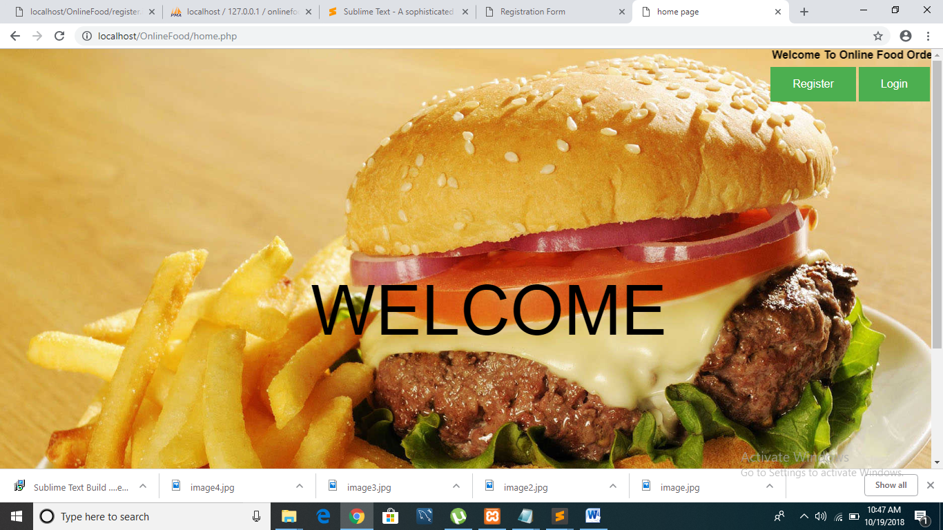

* Login Page

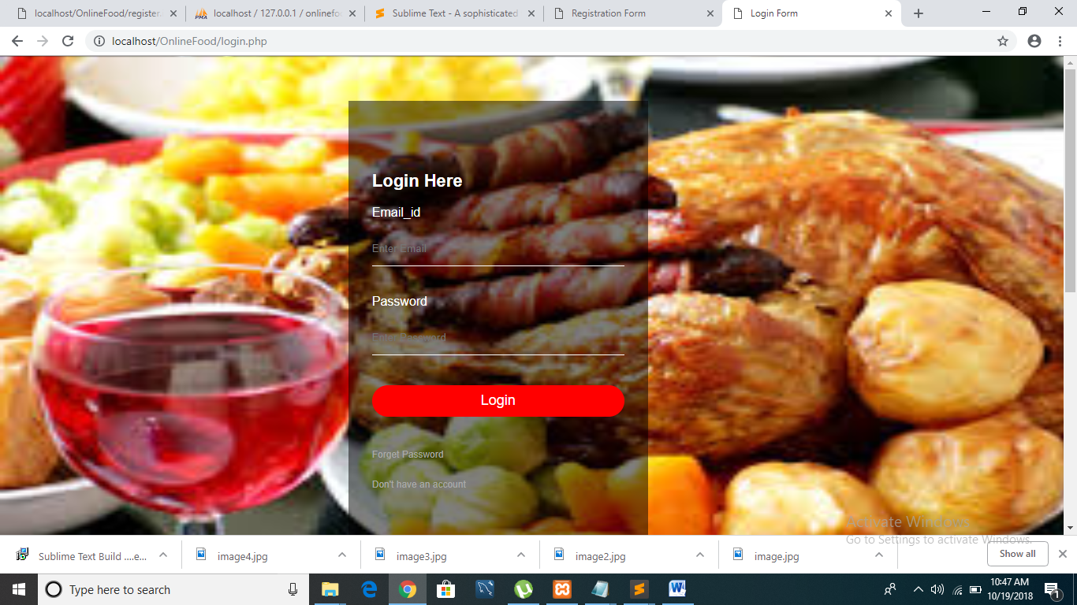

* Registration Page

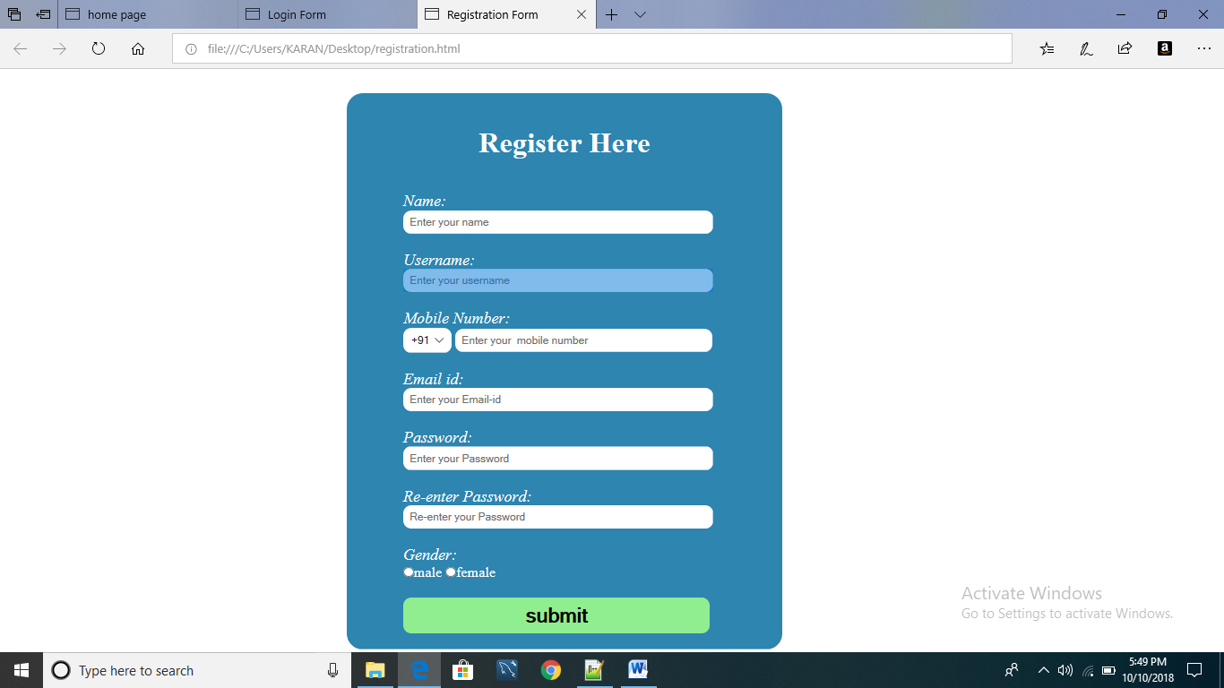

* Menu Page – Cuisine Types

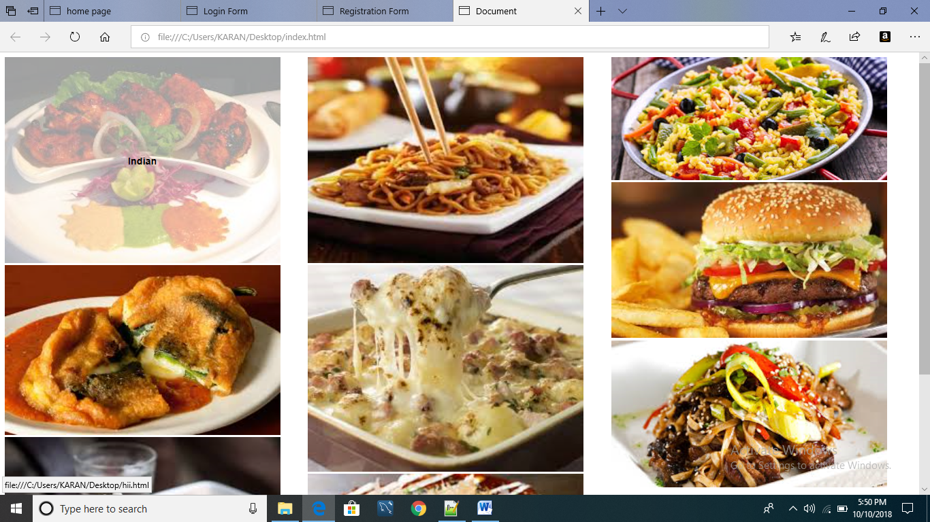

* Menu Page – Dish Types

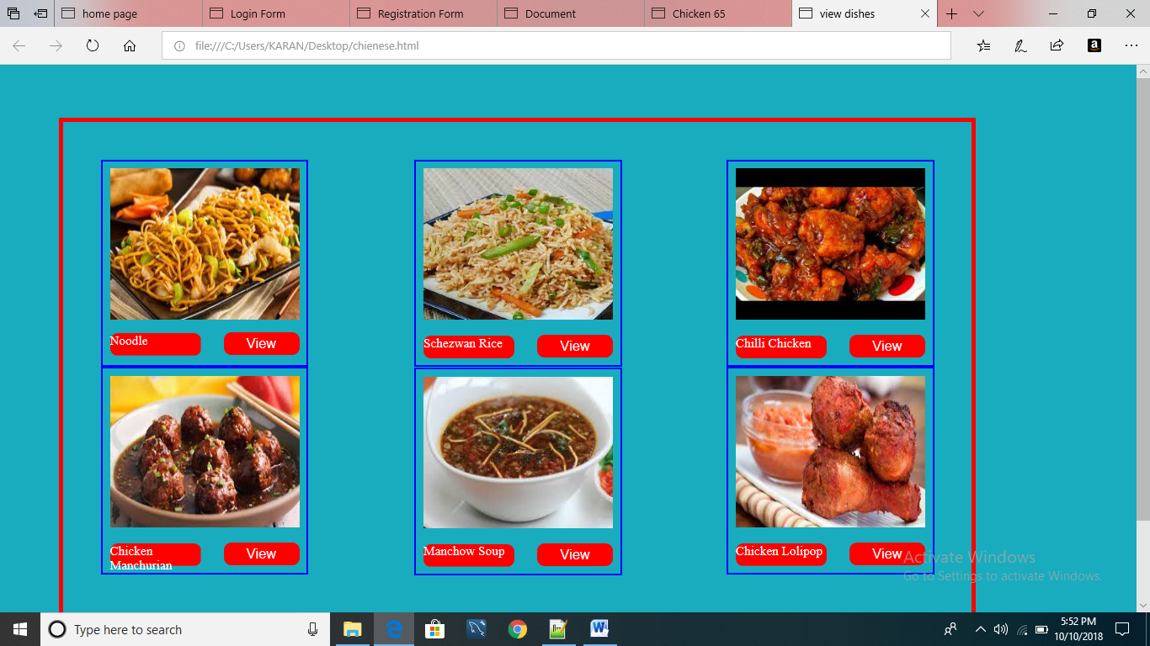

* Menu Page – Dish Details

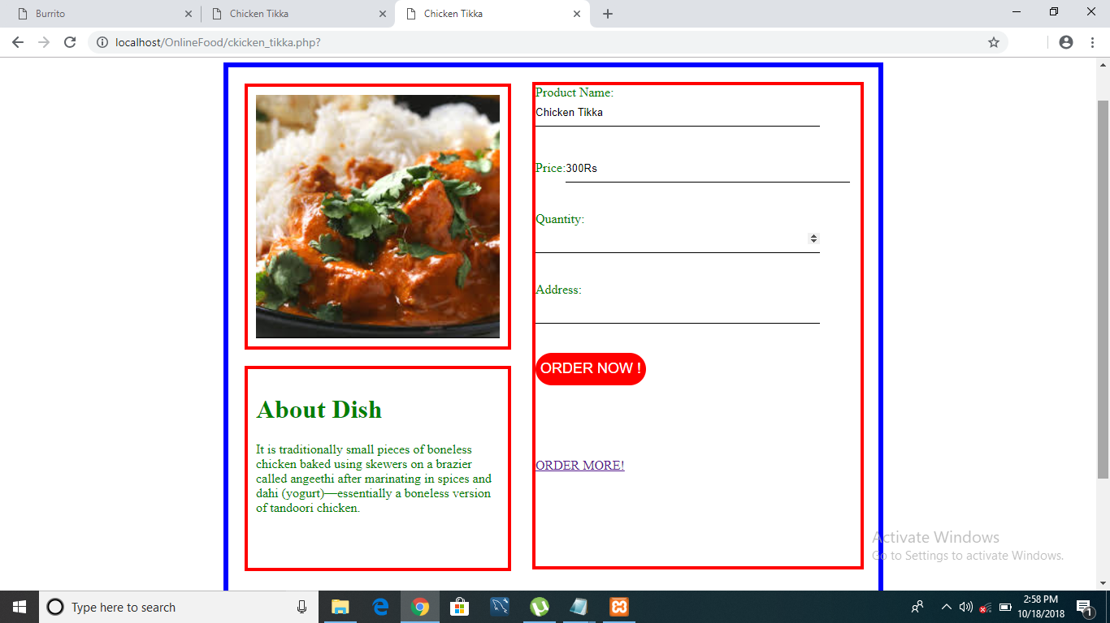

**Chapter IV**

**4.1. Conclusion**

This is to conclude that the project that we undertook will fulfill the requirements of online food ordering and the development of online food ordering system involved many phases. The approach used is a top-down one concentrating on what first, then howand moving to successive levels of details.

**4.2. Future Scope**

The project that we have made is to ensure that the website could be valid in real life challenging world. But still there can be some future scope of the website as it can be extended to improve more efficiency.

**References**

**ASME standard** **Book:**

[1] Advance Internet Technology,”Deven Shah” Published By Dreamtech.

**Website:**

[1] [www.w3school.com](http://www.w3school.com).

[2] [www.quora.com](http://www.quora.com)

[3] [www.github.com](http://www.github.com)